Requirements and Guidelines for PLASMAROFR2 Abstract

First author's name (e.g. Raoul B. Durand)¹, Second author's name², ...

¹ First author's affiliation, City, Zip code, Country
² Second author's affiliation, City, Zip code, Country
E-mail: myemail@home.com

The abstract should be in English and within one-page limit. Please follow the format and style described in this template.

Please use A4 (210 mm x 297 mm) paper size. The abstract should not exceed one A4 page, including figures, with page margins of 25 mm all around. Use font type Times, with single spaced lines [1] [2].

Title of the paper (14 points, bold) is followed by one blank line. The presenting author’s name should be underlined. Author’s affiliations (12 points, italic, centered) and email address of the contact person are written in separate rows.

Body text (12 points) in paragraphs is not indented, only separated by one blank line.

Figures should be placed before the references [3] and centered. The figure caption follows the style below.
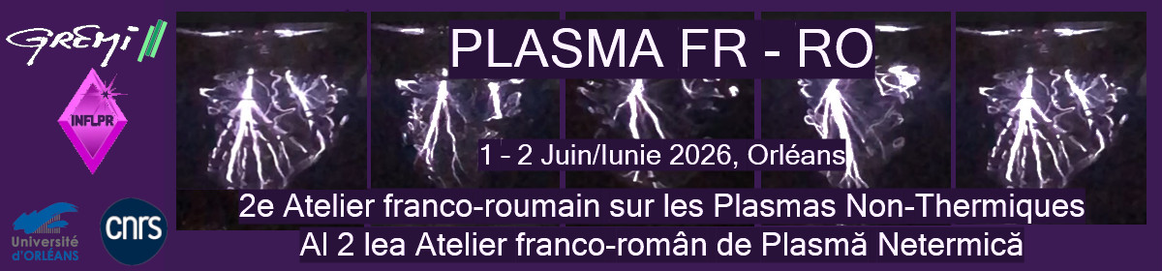
Figure 1: My caption

References should be indicated in the text in brackets and listed at the end of the paper (12 points).

The submission of your abstract in Acrobat pdf format must be made via the internet site https://plasmarofr2.sciencesconf.org/ before April 1st, 2026.

Acknowledgments may be addressed as the last paragraph of the text body.

References

[1] Abitbol G., Ramones J., York T., Journal of Gas Discharges (2004), 4, 591–601.
[2] Johanson S., Forget G., Princeton University Press (1998), Princeton, NJ, USA, 140–156.
[3] Asimov I., Science Press (1986), Olivet (France), 1–231.

